COMPUTER PROGRAMMING LAB 10

# EXAMPLE NO 1:

using System;

namespace

{

class Program

{

static void AreaOfRectangle(int L, int B)

{

int area = L * B;

Console.WriteLine("Area of Rectangle={0}", area);

}

static float AreaOfCircle(int r)

{

float pi = 3.142f;

float area1 = pi * r * r; return area1;

}

static void DisplayTitle()

{

Console.WriteLine("FUNCTIONS LAB");

}

static void Main(string[] args)

{

DisplayTitle(); int L, B, R;

float areaofcircle;

Console.WriteLine("Enter the Lenght of Rectangle"); L = Convert.ToInt32(Console.ReadLine()); Console.WriteLine("Enter the Breath of Rectangle"); B = Convert.ToInt32(Console.ReadLine()); Console.WriteLine("Enter the Radius of Circle");

R = Convert.ToInt32(Console.ReadLine()); AreaOfRectangle(L, B);

areaofcircle = AreaOfCircle(R); Console.WriteLine("Area of Circle={0}", areaofcircle);

}

}

}

# OUTPUT:

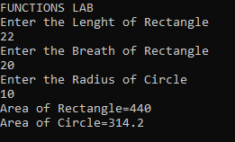

**TASK 01:**

using System;

namespace

{

class Program

{

static void cubeAndSquare(int num1)

{

int sum = num1 * num1;

int cube = num1 * num1 * num1;

Console.WriteLine("Square is {0} and Cube is {1}", sum, cube);

}

static void Main(string[] args)

{

int num1;

Console.WriteLine("Enter Number"); num1 = int.Parse(Console.ReadLine()); cubeAndSquare(num1);

}

}

}

# OUTPUT:

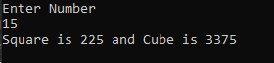

**TASK 02:**

using System;

namespace

{

class Program

{

static void CalculateTable(int num, int start, int end)

{

for (int i = start; i <= end; i++)

{

Console.WriteLine("{0} x {1} = {2}", num, i, num * i);

}

}

static void Main(string[] args)

{

Console.WriteLine("Enter any Number whose Table you want to print"); int num1 = int.Parse(Console.ReadLine());

Console.WriteLine("Enter The Starting point of Table"); int Start = int.Parse(Console.ReadLine()); Console.WriteLine("Enter the Ending point of Table"); int End = int.Parse(Console.ReadLine()); CalculateTable(num1, Start, End);

}

}

}

# OUTPUT:

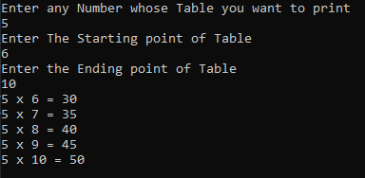

**TASK 03:**

using System;

namespace

{

class Program

{

static void MinMaxFunction(int[] array, int length)

{

int min = 0, max = 0;

for (int i = 0; i < length; i++)

{

Console.WriteLine("Enter Num {0}", i + 1); array[i] = int.Parse(Console.ReadLine());

if (i == 0)

{

min = array[i]; max = array[i];

}

if (min > array[i])

{

min = array[i];

}

if (max < array[i])

{

max = array[i];

}

}

Console.WriteLine("min = " + min); Console.WriteLine("max = " + max);

}

static void Main(string[] args)

{

Console.WriteLine("Enter Length of Array"); int Length = int.Parse(Console.ReadLine()); int[] Array = new int[Length]; MinMaxFunction(Array, Length);

}

}

}

# OUTPUT:

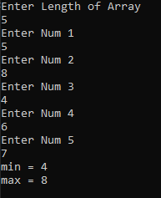

TASK 04:

namespace

{

class Program

{

static void ArrayRevFunction(int[] array, int length)

{

for (int i = 0; i < length; i++)

{

Console.WriteLine("Enter Num {0}", i + 1); array[i] = int.Parse(Console.ReadLine());

}

Console.WriteLine("Reverse Array: "); for (int i = length - 1; i >= 0; i--)

{

Console.WriteLine("{0}", array[i]);

}

}

static void Main(string[] args)

{

Console.WriteLine("Enter Length of Array"); int Length = int.Parse(Console.ReadLine()); int[] Array = new int[Length]; ArrayRevFunction(Array, Length);

}

}

}

# OUTPUT:

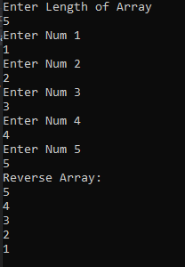

**TASK 05:**

using System;

using System.Collections.Generic; using System.ComponentModel; using System.Data;

using System.Drawing; using System.Linq; using System.Text;

using System.Threading.Tasks; using System.Windows.Forms;

namespace WindowsFormsApp1

{

public partial class Form1 : Form

{

public Form1()

{

InitializeComponent();

}

static void add(int num1, int num2)

{

int sum=num1 + num2; MessageBox.Show("The sum is" + sum);

}

static void sub(int num1, int num2)

{

int sub=num1 - num2; MessageBox.Show("The sub is" + sub);

}

static void mul(int num1, int num2)

{

int mul=num1 * num2; MessageBox.Show("The multiply is" + mul);

}

static void div(int num1, int num2)

{

float div=Convert.ToSingle(num1)/Convert.ToSingle(num2); MessageBox.Show("The Divide is" + div);

}

private void label1_Click(object sender, EventArgs e)

{}

private void label2_Click(object sender, EventArgs e)

{}

private void radioButton1_CheckedChanged(object sender, EventArgs e)

{}

private void label3_Click(object sender, EventArgs e)

{}

private void button1_Click(object sender, EventArgs e)

{

int num1 = Convert.ToInt32(txtNum1.Text); int num2 = Convert.ToInt32(txtNum2.Text); if(rbAdd.Checked==true)

{

add(num1, num2);

}

else if(rbSub.Checked==true)

{

sub(num1, num2);

}

else if(rbDiv.Checked==true)

{

div(num1, num2);

}

else if (rbMul.Checked == true)

{mul(num1, num2);} else{

MessageBox.Show("Invalid input");

}

}

}

}

# OUTPUT:

